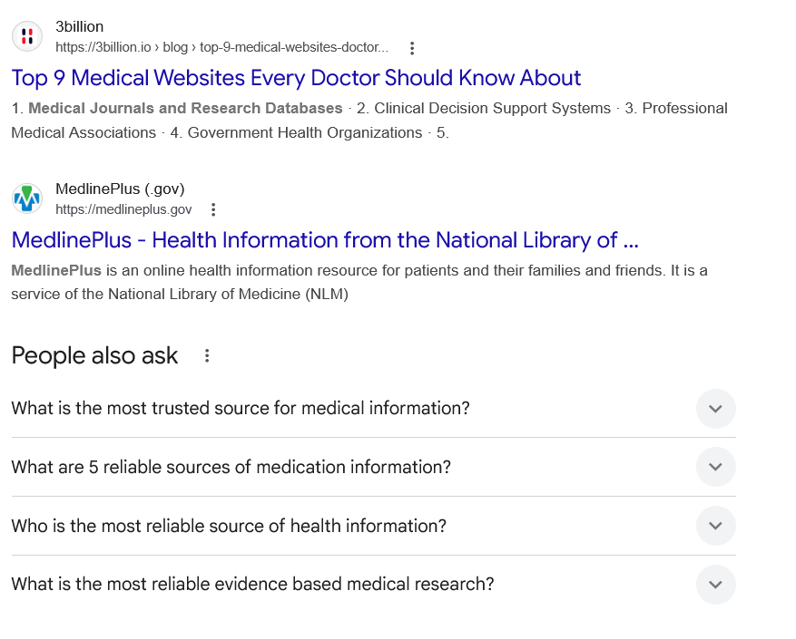
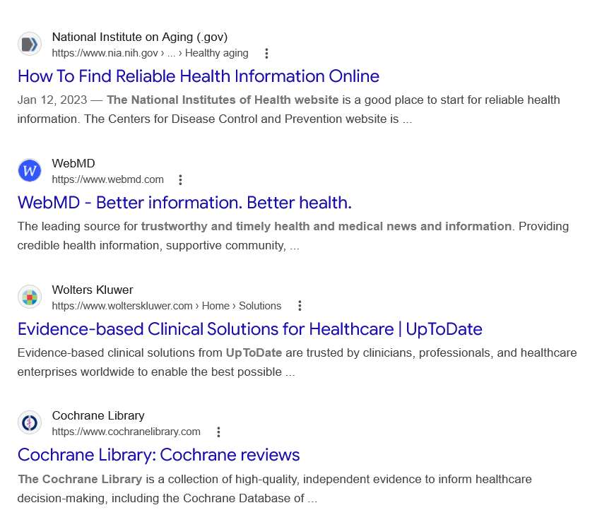
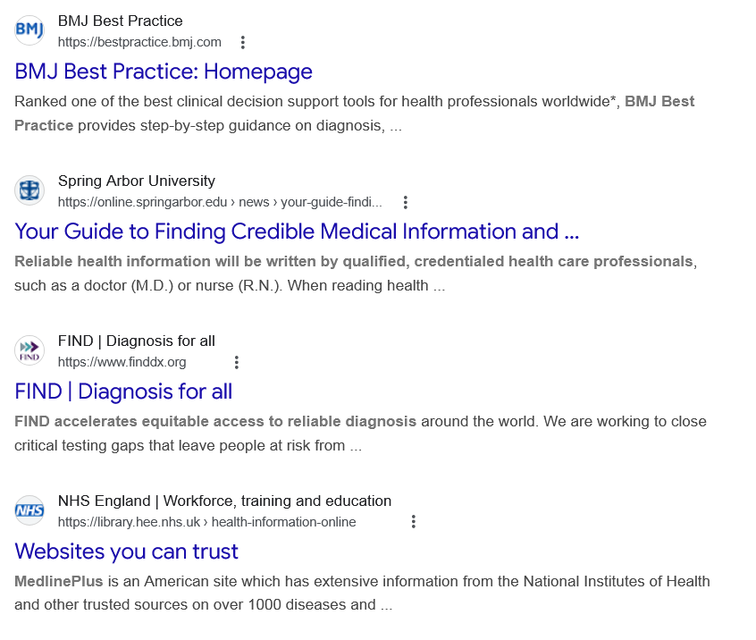
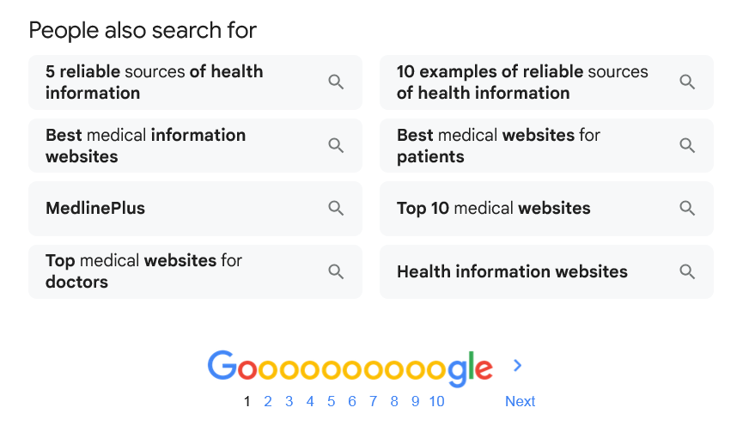

Web results

Top 9 Medical Websites Every Doctor Should Know About

3billion
https://3billion.io › blog › top-9-medical-websites-doctor...

3billion
https://3billion.io › blog › top-9-medical-websites-doctor...
1. Medical Journals and Research Databases · 2. Clinical Decision Support Systems · 3. Professional Medical Associations · 4. Government Health Organizations · 5.

MedlinePlus - Health Information from the National Library of ...

MedlinePlus (.gov)
https://medlineplus.gov

MedlinePlus (.gov)
https://medlineplus.gov
MedlinePlus is an online health information resource for patients and their families and friends. It is a service of the National Library of Medicine (NLM)
People also ask
What is the most trusted source for medical information?
As a rule, health websites sponsored by federal government agencies are accurate sources of information. You can reach all federal websites by visiting www.usa.gov. Medical and health care organizations, hospitals, and academic medical institutions may also be reliable sources of health information.Jan 12, 2023

How To Find Reliable Health Information Online

National Institute on Aging (.gov)
https://www.nia.nih.gov › ... › Healthy aging

National Institute on Aging (.gov)
https://www.nia.nih.gov › ... › Healthy aging
What are 5 reliable sources of medication information?
Here are 5 online resources for medical information that every patient can trust.
- Overall Health Information: MedlinePlus.
- Drug Information: Daily Med.
- Medical Procedures: Mayo Clinic and Johns Hopkins.
- Dietary Supplements: NIH Office of Dietary Supplement.

5 Reliable Sources of Medical Information Online - Patient Helpline

Patient Helpline
https://patienthelpline.org › resource › reliable-medical-i...

Patient Helpline
https://patienthelpline.org › resource › reliable-medical-i...
Who is the most reliable source of health information?
What are the most reliable sources of health information?
- National Institutes of Health (NIH)
- Centers for Disease Control and Prevention (CDC)
- National Health Service (NHS)
- World Health Organization (WHO)
- National Library of Medicine (Stat Pearls, MedlinePlus)
- Food and Drug Administration (FDA)
Jun 23, 2025

Finding Reliable Sources of Health Information Online - Healthline

Healthline
https://www.healthline.com › health › what-is-the-most-r...

Healthline
https://www.healthline.com › health › what-is-the-most-r...
What is the most reliable evidence based medical research?
The Cochrane Library is a unique source of reliable and up-to-date information on the effects of interventions in health care. Published on a quarterly basis, The Cochrane Library is designed to provide information and evidence to support decisions taken in health care and to inform those receiving care.Feb 25, 2026

Resources for Locating Evidence - Evidence Based Medicine

Welch Medical Library Guides
https://browse.welch.jhmi.edu › EBM

Welch Medical Library Guides
https://browse.welch.jhmi.edu › EBM

Web results

How To Find Reliable Health Information Online

National Institute on Aging (.gov)
https://www.nia.nih.gov › ... › Healthy aging

National Institute on Aging (.gov)
https://www.nia.nih.gov › ... › Healthy aging
Jan 12, 2023 — The National Institutes of Health website is a good place to start for reliable health information. The Centers for Disease Control and Prevention website is ...

WebMD - Better information. Better health.

WebMD
https://www.webmd.com

WebMD
https://www.webmd.com
The leading source for trustworthy and timely health and medical news and information. Providing credible health information, supportive community, ...

Evidence-based Clinical Solutions for Healthcare | UpToDate

Wolters Kluwer
https://www.wolterskluwer.com › Home › Solutions

Wolters Kluwer
https://www.wolterskluwer.com › Home › Solutions
Evidence-based clinical solutions from UpToDate are trusted by clinicians, professionals, and healthcare enterprises worldwide to enable the best possible ...

Cochrane Library: Cochrane reviews

Cochrane Library
https://www.cochranelibrary.com

Cochrane Library
https://www.cochranelibrary.com
The Cochrane Library is a collection of high-quality, independent evidence to inform healthcare decision-making, including the Cochrane Database of ...

BMJ Best Practice: Homepage

BMJ Best Practice
https://bestpractice.bmj.com

BMJ Best Practice
https://bestpractice.bmj.com
Ranked one of the best clinical decision support tools for health professionals worldwide*, BMJ Best Practice provides step-by-step guidance on diagnosis, ...

Your Guide to Finding Credible Medical Information and ...

Spring Arbor University
https://online.springarbor.edu › news › your-guide-findi...

Spring Arbor University
https://online.springarbor.edu › news › your-guide-findi...
Reliable health information will be written by qualified, credentialed health care professionals, such as a doctor (M.D.) or nurse (R.N.). When reading health ...

FIND | Diagnosis for all

FIND | Diagnosis for all
https://www.finddx.org

FIND | Diagnosis for all
https://www.finddx.org
FIND accelerates equitable access to reliable diagnosis around the world. We are working to close critical testing gaps that leave people at risk from ...

Websites you can trust

NHS England | Workforce, training and education
https://library.hee.nhs.uk › health-information-online

NHS England | Workforce, training and education
https://library.hee.nhs.uk › health-information-online
MedlinePlus is an American site which has extensive information from the National Institutes of Health and other trusted sources on over 1000 diseases and ...
People also search for

5 reliable sources of health information

Best medical information websites

MedlinePlus

Top medical websites for doctors

10 examples of reliable sources of health information

Best medical websites for patients

Top 10 medical websites

Health information websites

Page navigation
 | 1 | 2 | 3 | 4 | 5 | 6 | 7 | 8 | 9 | 10 | Next

